Transferring Photos form your iPhone to Your Computer Using Wi-Fi Transfer
If Wi-Fi Transfer is already installed on your iPhone, open it. If it isn’t, download it from the App Store
https://apps.apple.com/us/app/wifi-photo-transfer/id380326191
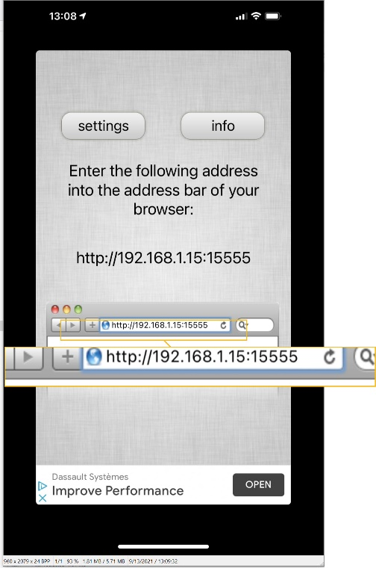

Open that program and note the URL that it lists.
In the case of this example, the URL is
https://192.168.1.15:15555
IMPORTANT: Do not close the program on
your phone until you have transferred all of
the images that you will choose in the next
step.

Open your browser of choice and type the URL into a new tab. Press Enter
This will open up a listing of the Picture folders on your iPhone
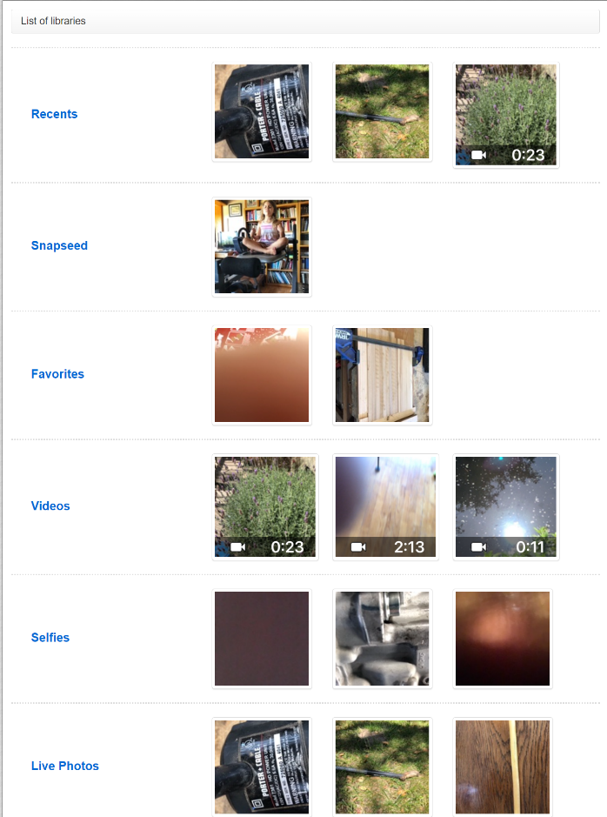
In this example, I will choose images from the Recents folder

Enter that folder by left clicking on it.
Click the blue button labeled
Select the images that you wish to download by checking the appropriate box below each image or specify the range by noting the numbering of the images and typing it in the Select Range box

Click Apply Selection or Download Selected

The images that you chose will be downloaded to the Downloads folder on your computer. They will be in a Zip file; a compressed state that has to be unzipped before you can use the images.

Open the zipped folder from the Downloads folder
Like any other content that you download, it shows up in a box. In the case of Google Chrome, that box is in the lower left hand corner of the screen

You can either click on the box indicated by the arrow or navigate to the location of your Downloads folder.

Unzip the folder by double clicking the Extract All button

For the sake of simplicity, extract (unzip) the folder to the Downloads folder. A new folder called Images will be created inside the Downloads folder

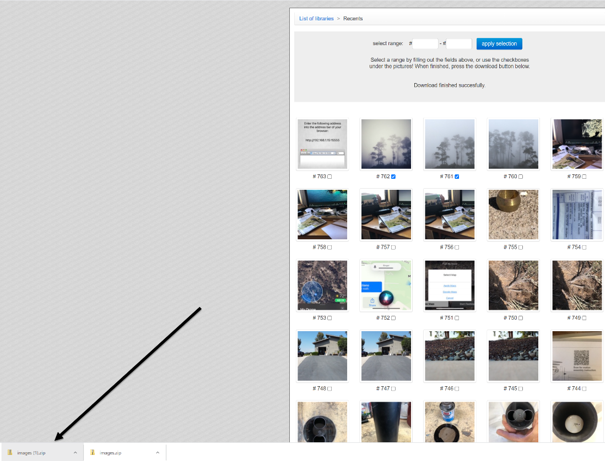
You now have completed the process of copying the images that you select on your iPhone to your computer.

