Clearing Cached Images and Files in Google Chrome
I recently, with my Google Chrome browser, downloaded from my web site an Excel spreadsheet.
I decided to make some changes and then upload them.
I then downloaded the updated file. It had not updated. I refreshed the screen and downloaded it again. Still no change.
Next, using Microsoft Edge, I downloaded the file again. It was the updated version.
I suspected that Chrome was retrieving the file from cache instead of downloading an new copy.
To verify this, I returned to Chrome and clicked on the three vertical dots highlighted in the image below ↓
Next, I clicked on Settings
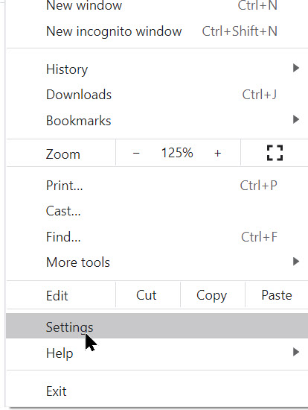

and then Clear Browsing Data
(See screenshot below)

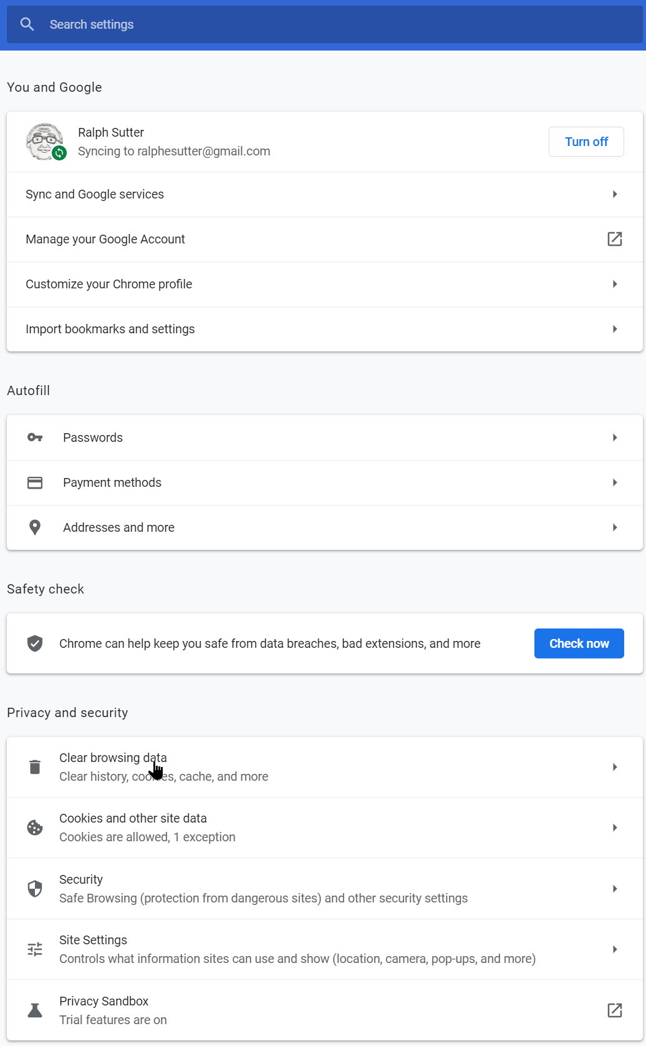

→

Finally, I checked Cached images and files/Clear data

When I once again downloaded the file in Chrome. This time, I got the updated version. This solution applies not only to Excel but to any downloaded file.

