February 4th, 2018 Second Session Notes by Ralph Sutter
Network Mapping Project
I used the following software to diagram my home computer network
Gliffy: https://go.gliffy.com/go/share/soyahcg4ptmbf5hge2ke (15 day free trial, then subscription)
Microsoft Office Publisher (paid program, included in several Microsoft Office suites)
Microsoft Word (paid program, included in several Microsoft Office suites)
Adobe Photoshop Elements 15 (paid program)
LibreOffice 6 Draw http://www.libreoffice.org/download/download/ (open source freeware, download version 5. It is a great improvement over version 5.4.
Here are links to sites that make recommendations for software for diagramming networks
https://www.neweggbusiness.com/smartbuyer/over-easy/5-free-tools-to-draw-a-network-diagram/ https://www.pcwdld.com/top-10-network-diagram-topology-and-mapping-software
Learn more about my network: www.fullbean.com/network
Here, I have gathered copyright free network icons that can be used to draw your own diagram. www.fullbean.com/network/Icons
Many similar icons are readily available on line as clipart from other sources.:
Here are two links to on-line reviews of paid and freeware useful in network mapping
https://www.neweggbusiness.com/smartbuyer/over-easy/5-free-tools-to-draw-a-network-diagram/
https://www.pcwdld.com/top-10-network-diagram-topology-and-mapping-software
A useful device for drawing lines from one icon to another is the Connector tool. It is found in multiple drawing programs including Gliffy and LibreOffice Draw 6
How to install Libreoffice 6.0 https://websiteforstudents.com/install-libreoffice-6-0-ubuntu-16-04-17-04-17-10/c
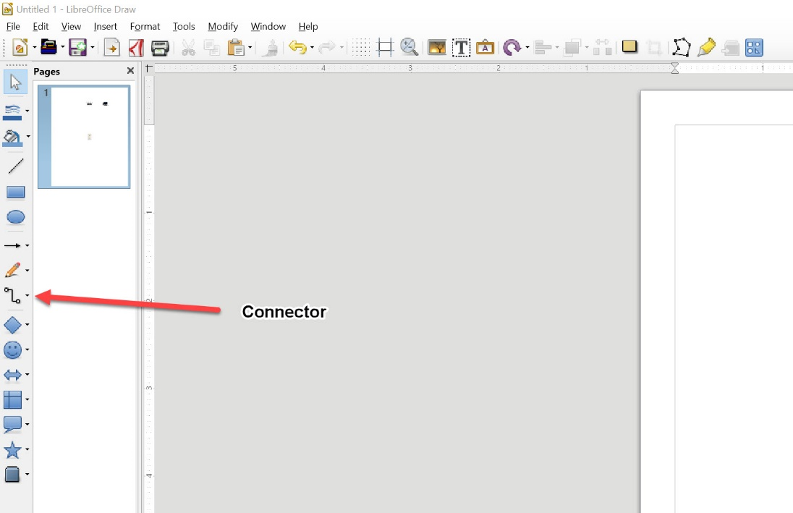
Detail of LibreOffice 6 Draw
To launch LibreOffice 6 from the terminal type libre then hit the Tab to show all listing that contain libre.
The command to launch LibreOffice 6 is libreoffice6.0
Change Font Size: Insert text with Text tool then Edit Style and specify size/font
Ralph Sutter

