SLO Bytes Second Session
04/07/19
Setting Up a Netgear Orbi Network
My Orbi setup consists of the Netgear Orbi RBK43-200NAS Router and two satellite devices. Think of the satellites as self-configuring wireless access points. The three Orbi devices communicate with one another to create the mesh network. They can do this via a LAN cable or wirelessly with any combination possible between them.
Product Information
Quick Start Guide: : http://www.downloads.netgear.com/files/GDC/RBK43/RBK43_QSG_EN.pdf
Documentation: https://www.netgear.com/support/product/RBK43.aspx#docs
Setup:
Option A: From Netgear Orbi Instruction Sheet, scan QR code, downloading Orbi app for iPhone.
Install Netgear Orbi App on iPhone
Option B: Install from an Internet connected computer. Point your browser to http://orbilogin.net/BRS_index.htm
If you return to this URL after having changed the default user password, clicking on this URL redirects you to https://www.netgear.com/home/products/networking/orbi/orbilogin.aspx
with the unsettling notification “Looks like you’re not connected to your Orbi’s WiFi network. Don’t worry, it happens to the best of us. Try the following steps to get connected:”
Ignore this misinformation and in your browser’s address bar, type in http://192.168.1.1 or whatever the local address of your router is. Common addresses are 192.168.1.1 and 192.168.1.2
If you simply click on the above hyperlink from a Word document, you end up with this screen
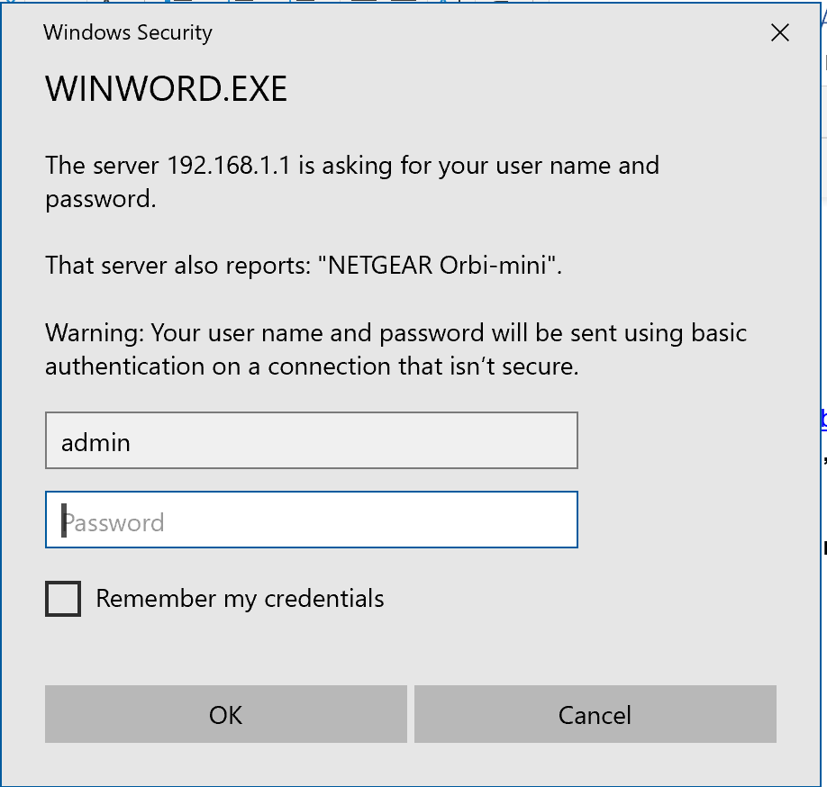
Enter your password here
If you type in http://192.168.1.1 you will get a different screen but will also be asked your Userid and Password
Below is a sample confirmation screen
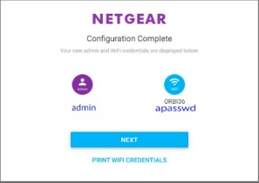
My Internet comes from Advanced Wireless in Santa Maria via terrestrial satellite. I opted to install from a computer. I disconnected my previous router, a Netgear 7900 and connected the feed from Advanced Wireless to the Internet Port of the Orbi Base Station and turned the Orbi on.
I then placed the 2 Orbi Satellite Stations in different areas of my home. I tried connecting them through the Ethernet ports on the three devices but had stronger signals and more consistent results by connecting wirelessly. This surprised me greatly. So that I could easily move the satellites from place to place without powering them off, I used very long extension cords
The Orbi software shows you the signal status and strength of the two satellites. It also shows what devices are connected to the mesh network. See here.
The switches on the Orbi network are here
Ralph Sutter

