**Degrees of Coffee Roasting**

|  |  |  |  |  |  |  |
| --- | --- | --- | --- | --- | --- | --- |
| **Sweet Marias Chart** | |  | **George Steinert’s Chart** | | **Revised Sweet Marias** | |
| Name of Roast | Internal Bean Temperature | Temperature by Thermal Probe | 1st Crack Begins | 401 f |  |  |
| Yellow Stage | 200-250 degrees f |  | 1st Crack Under Way | 415 f | Yellow Tan | 345 f |
| Light Brown | 250-300 degrees f |  |  |  | Light Brown | 370 f |
| First Crack Begins | 355 f | 395-405 f |  |  | Brown | 393 f |
|  |  | 425-435 f |  |  | 1st Crack | 401 f |
|  |  | 438-448 f |  |  | 1st Crack underway | 415 f |
| City Roast, City+ Roast | 400 – 415 f |  | City Roast | 426 f | End 1st Crack (City Roast) | 426 f |
|  |  |  |  |  |  |  |
|  |  |  | City+ | 435 f | City + Roast | 435 f |
|  |  |  |  |  |  |  |
| Full City Roast, Full City+ Roast | 415-425 f |  | Full City | 446 f | Full City verge of 2nd Crack | 444 f |
| Full City Roast+ | 430-445 f | 450 f | Full City+ | 454 f | Full City+ | 454 f |
|  |  |  |  |  |  |  |
| Vienna Roast | 450-465 f | 455-465 f | Vienna (Light French) | 465 f | Vienna | 465 f |
| Full French Roast -Italian Roast | 475-510 f | 470-490 f | Full French | 474 f | Full French | 474 f |
| Spanish Roast | 520-530 degrees f |  |  |  |  |  |
|  |  |  |  |  |  |  |

Compiled from information found at Sweet Marias; <https://legacy.sweetmarias.com/library/content/using-sight-determine-degree-roast>

Do not exceed 450° F when roasting

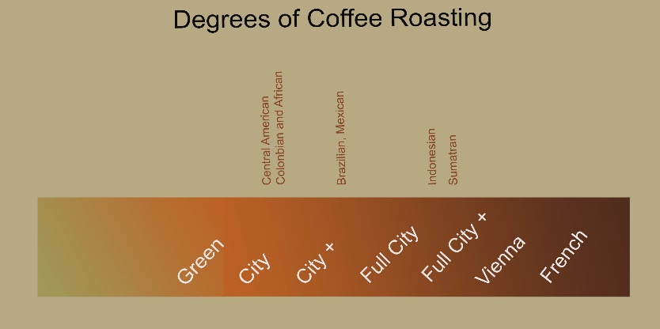

|  |  |  |  |  |  |  |  |  |
| --- | --- | --- | --- | --- | --- | --- | --- | --- |
| **The Stages of Coffee Roasting** | | | | | | | | |
| **Stage** | **Unroasted** | **Cinnamon** | **American** | **Full City** | **Vienna** | **Espresso** | **French** | **Italian** |
|  | Raw bean is 12% water by mass. | Volatile vapors cause bean to expand. | Bean is still expanding. Acidity content higher than sugar. | Bean at max expansion. Balance of acids and sugars. | More gasses are lost. | Aromas decrease. Sugars caramelize. | Acids radically decrease. Sugars caramelize. | Bean loses characteristic coffee flavor. |
| **Mass Loss** | 0.0% | 13.0% | 14.0% | 16.5% | 17.0% | 18.0% | 19.0% | 20.0% |
| **Temp. Degrees F** | Room Temp. | 380-400 | 400-435 | 435-445 | 445-455 | 455-465 | 465-475 | 475-480 |
|  | http://www.coffeeman.com/coffeeman/roasting/bean1.gif | http://www.coffeeman.com/coffeeman/roasting/bean2.gif | http://www.coffeeman.com/coffeeman/roasting/bean3.gif | http://www.coffeeman.com/coffeeman/roasting/bean4.gif | http://www.coffeeman.com/coffeeman/roasting/bean5.gif | http://www.coffeeman.com/coffeeman/roasting/bean6.gif | http://www.coffeeman.com/coffeeman/roasting/bean7.gif | http://www.coffeeman.com/coffeeman/roasting/bean8.gif |
| **Bean Appearance** | Green and smooth. | Light brown. Smells of baking bread. | Darker brown. Larger in size | Bean chips begin to fly off. Smooth and brown. Oil is visible. | Dark brown. Beans have oil on them. | Black and oily. | Dark black. Very oily. Burnt smell. | Black, oil is dried off. |

<http://www.coffeeman.com/coffeeman/coffee_roasting.htm>

The information below is my own. It did not come from the above web site. (Ralph Sutter)

|  |  |  |  |
| --- | --- | --- | --- |
| **Name of Style** | **Roast Color** | **Stage** | **Appearance of Bean** |
| --- | Very light brown | End of drying | Dry |
| Cinnamon | light brown | Start of First Crack | Dry |
| Light | Light-medium brown | First Crack | Dry |
| City | Medium brown | End of First Crack | Dry |
| Full City (or City Plus) | Medium-dark brown | Start of Second Crack | Dry/Shiny |
| Viennese | Dark brown | Slow Second Crack | Spots of oil |
| French | Very dark brown | Fast Second Crack | Very shiny/oily |
| Spanish | Extremely dark brown | Fast Second Crack | Wet with oil |

A **City Plus** roast level means that the roast was stopped at the beginning of second crack.

Central American, Colombian and African Coffees: Very acidic or bright. Stop roast just at the end of **First Crack/City**.

Brazilian, Mexican and other Mild Coffees: Low acidity; Roast to between First and Second Crack; **City Plus**

Indonesian: Like Brazilian, Try roasting lightly. For espresso, roast to **Full City**

Sumatran or Sulawesi: Roast to **Full City or darker**. Good for blending

Degrees of Coffee Roasting

|  |  |  |  |  |  |
| --- | --- | --- | --- | --- | --- |
| **Degree of Roast** | **Image** | **Degree of Roast** | **Image** | **Degree of Roast** | **Image** |
| Yellow-Tan |  | **City Roast** |  | **Vienna (Light French)** |  |
| Light Brown |  | **City+** |  | **Full French** |  |
| Brown |  | **Full City** |  | **Fully Carbonized** |  |
| 1st Crack Begins |  | **Full City +** |  | **Immanent Fire** |  |