Notes for My First Whole Muscle Meat Dry Curing
I trimmed pork loin and ended up with 2894 grams of meat.
The meat was sliced into long strips
I separated the pork into 3 portions, two weighing approximately 1000 grams and one weighing approximately 894 grams
This is the recipe that I followed based on 1000 grams of trimmed pork
Ingredients
1000 grams trimmed pork
22.50 grams of Kosher salt ground fine
2.50 grams of Prague Powder #2
7.00 grams of sweet Paprika
1.00 grams of white sugar
3 grams of garlic powder ground fine
Diluted Bactoferm Mold 600 for mold culture (See Bactoferm Information Sheet below)
Instructions
Weigh all ingredients with a scale capable of measuring .01 grams.
This is critical with everything except the 1000 grams of pork
Cut the trimmed pork in strips 1 inch square and the full length of the pork loin
The pork should be chilled in the refrigerator before mixing it in the combined salts and spices.
Rub the pork in a bowl containing the blended spices making sure to coat the meat completely
Wrap the coated pork strips tightly in plastic wrap.
Each bundle was 1 inch thick and as wide as necessary with each strip placed firmly against the next
I then placed the three bundles in the refrigerator. I will leave them there for 10 days.
If I had sliced the meat thicker, I would leave them in the refrigerator longer.
The rule of thumb is at least one week in the refrigerator for every inch of meat
Drying Chamber Section
I chose to leave the strips of meat unwrapped not wrapped in muslin
I noted the beginning weight of each strip and the date when I placed it in the drying chamber
The drying chamber was set to 85% humidity with a temperature of 85 degrees Fahrenheit
Since the charcuterie drying chamber is located in an unheated shed, I added an infrared heat lamp to the chamber in addition to the refrigerator compressor
I sprayed the interior of the drying chamber with diluted bleach before hanging the meet inside it.
Mold Culture Information
I mixed up a 500ml batch of Bactoferm Mold 600. Here are the steps
Remove and correctly weigh 1.50 grams of Mold Culture.
Dissolve in 200ml (approx. 1 measuring cup) of lukewarm water (approx. 68°) and hold for 12 Hours.
Then dilute by adding 300ml of tap water
Fill a small spray bottle with the mold culture solution
Spray the meat with mold solution prior to placing in the drying chamber
After 24 hours, I checked and confirmed that a white grayish mold began to appear on the hanging pork
I then lowered the chamber temperature to 54 degrees F at 74% humidity
Bactoferm Information Sheet
I will dry the pork strips until the weight of each strip drops at least 35%
At that point, I will remove the finished meat from the chamber.

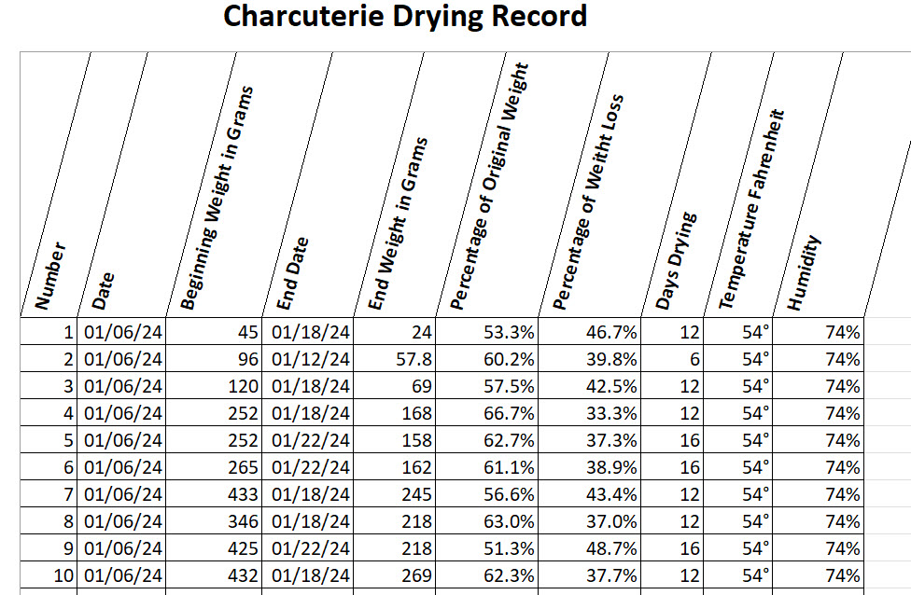

Dry Salami Recipe
1000 grams pork back fat
4000 Grams boneless pork shoulder butt, diced
124 grams kosher salt
15.4 grams Prague Powder #2
22 grams Mold 600
132 grams water
66 grams dextrose
26 grams fennel seeds, toasted and cracked
26 grams black pepper
13 grams minced garlic
275 ml Chianti or other dry Tuscan red wine
10 feet of hog casings
Directions
Grind partially frozen fat through a large die into a bowl resting in ice water
Combine pork with salt and Prague powder through a small die into a bowl resting in ice water
Combine the ground fat and ground pork in a mixing bowl , blend and refrigerate
Dissolve Mold 600 in water and add to meat blend then add remaining ingredients
Mix all ingredients well for 1 minute
Stuff the sausage into casings 12" per link
Poke any trapped air sections with a sausage picker NOTE: This is only necessary for meat stuffed in casings
Cover the sausage with a clean towel and leave out at room temperature (85 degrees F) for 12 hours to incubate sausage
Tag the sausage recording date and weight
Hang the sausage in the drying chamber at 60 degrees/60-70% humidity until it has lost 35% of its weight (now weighing 650 grams)\
Typical hang time for hog casings is 18 days

