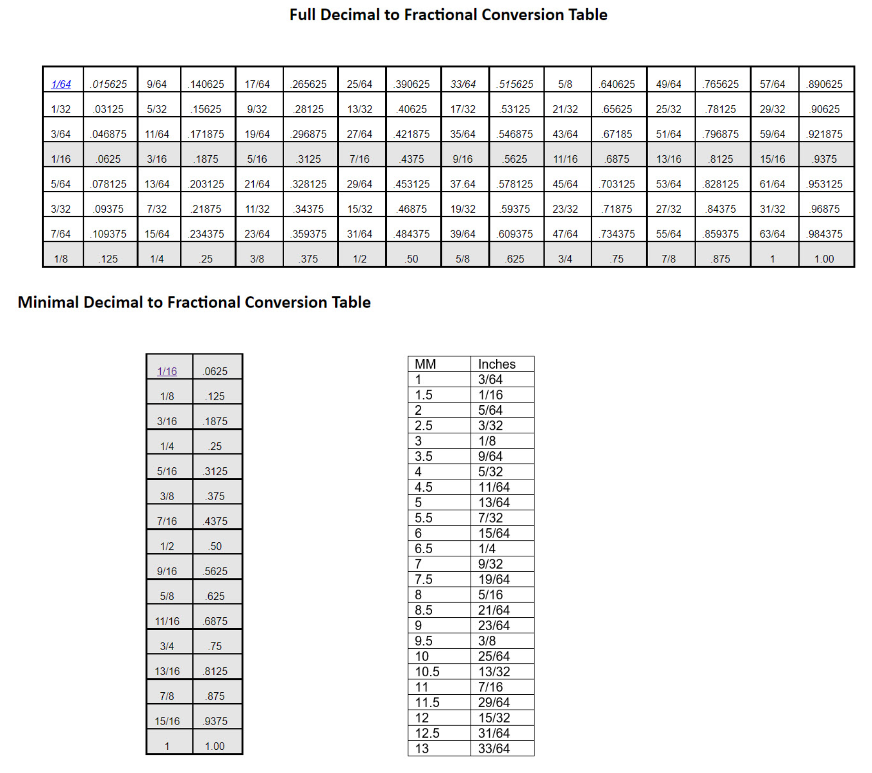

Turning Screwdriver Handles on a Wood Lathe
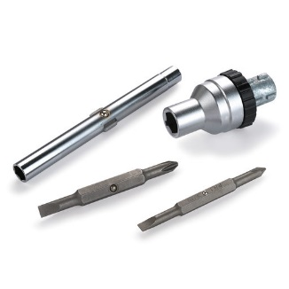
I enjoy turning screwdriver handles on a wood lathe. First I buy the metal parts of the tool on-line. I use several suppliers; Woodcraft.com and Penn State Industries. I prefer these kits because the screwdriver kit is a six way screwdriver that ratchets.

The first step is to select a blank for the handle. Sometimes, I choose an exotic hardwood. Other times, I create the blank in resin using Alumilite Clear Slow polyester casting resin.
The blank should measure at least 1 ¼” square and be an inch longer than the finished handle.
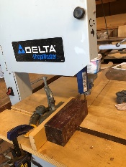
I cut the blank to shape on a band saw in the case of wooden handles and cast the resin blank inside a PVC pipe.

Next, I move to the lathe, mounting the blank in a pen chuck and drilling a ¾” diameter hole ½” deep using a Forstner bit mounted in a drill chuck.
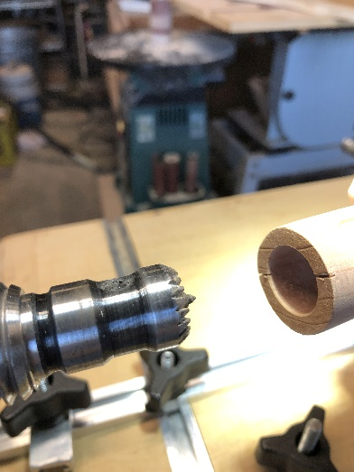
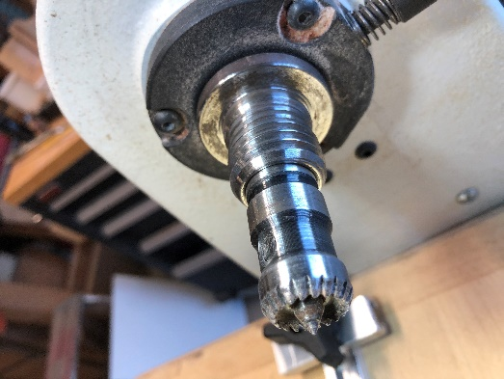
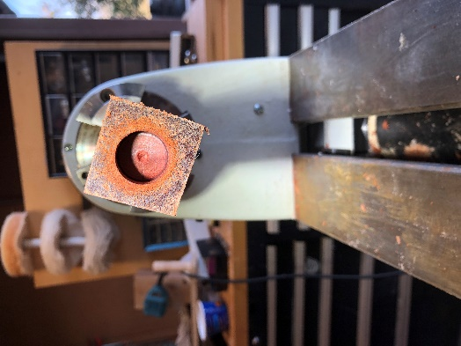

I then turn the blank to shape. The only critical dimension is the part of the handle next to the ratcheting mechanism. The diameter of the ratchet ring should match that of the handle where the two join together. Other than that, one can shape the handle as he or she sees fit.

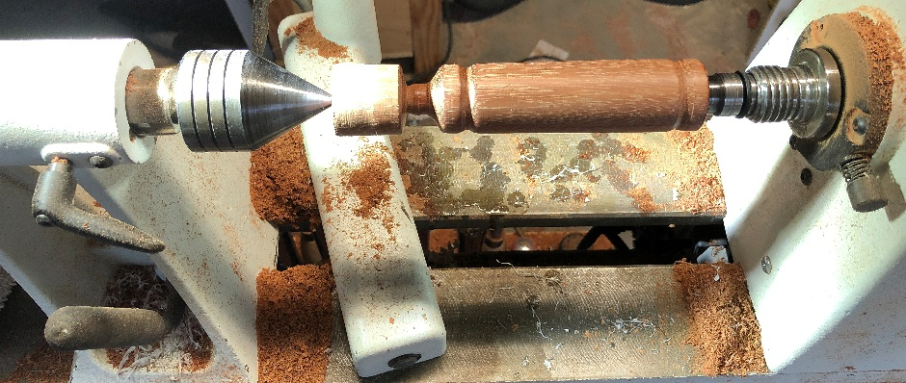
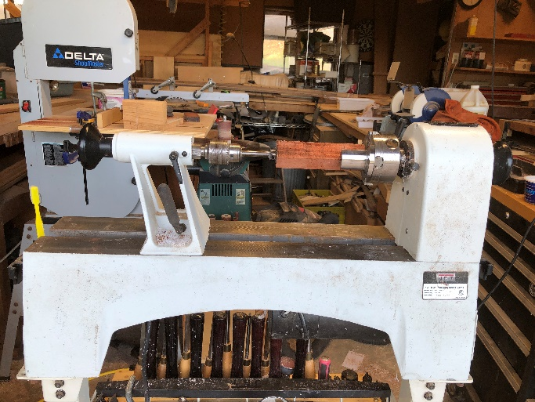

Note that the left side of the blank has not been trimmed to length. I do that off the lathe with a hand saw, sanding the end of the handle smooth before fluting
Fluting
Cutting a channel along the length of the work piece is called fluting
My lathe has an indexing feature that allows me to lock the spindle in any one of 24 positions. I lock the spindle at Marks 0, 7, 13 and 19, cutting a channel with a router and router jig at each position.
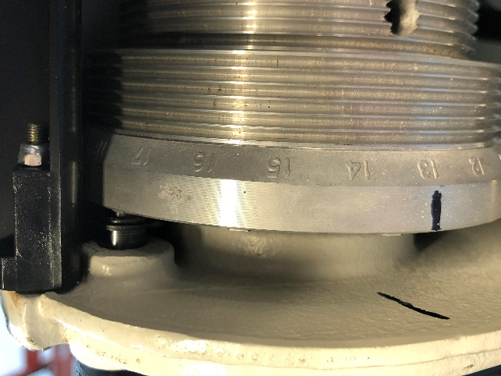
In order to flute accurately, I made a jig that holds a router with a fluting bit.
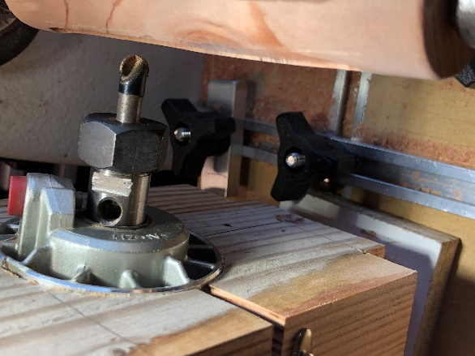
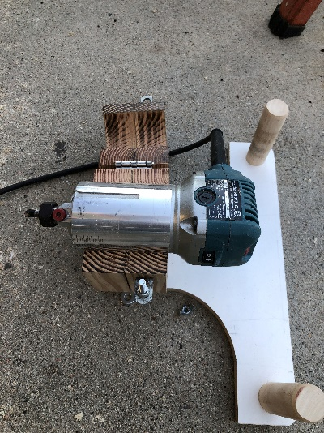
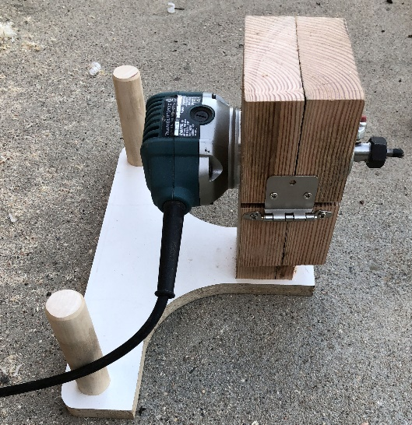
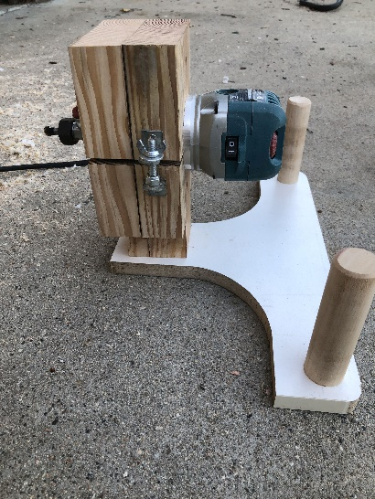
Here are some images of the router carrier

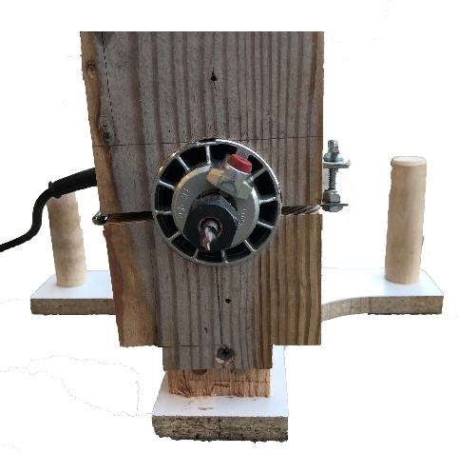
The router carrier is placed on a platform that overlays the lathe base and attaches to it with clamps that pass through the slot in the lathe bed.
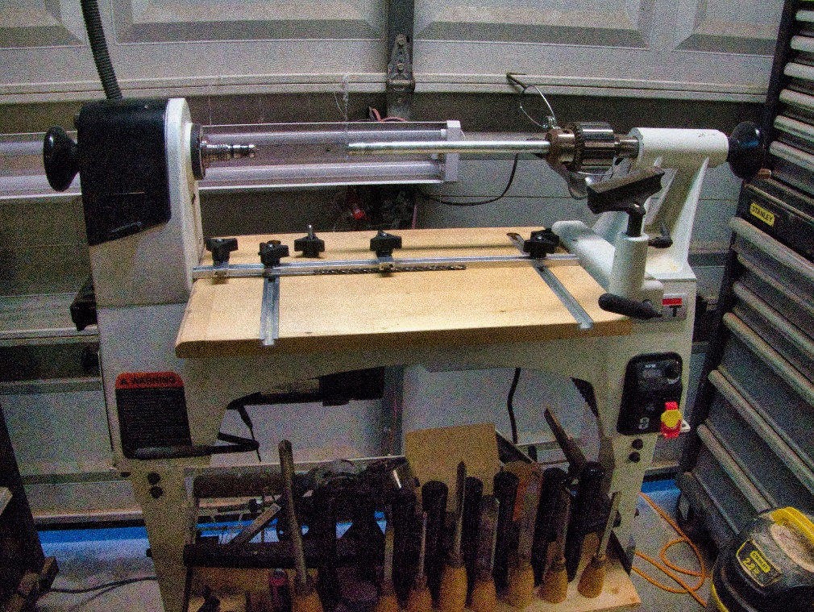
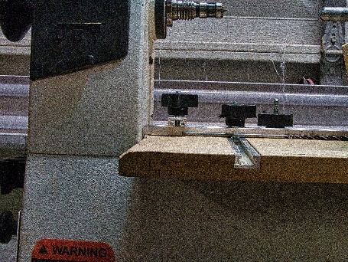
There are T slots in the platform to control the router movement both left to right and to depth. The 4 mm drill bit shown below serves as a spacer, determining the depth of the router cut. With the spacer removed, the router cuts a 4mm deep flute.

Here is an overhead shot of the setup
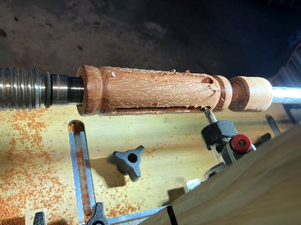
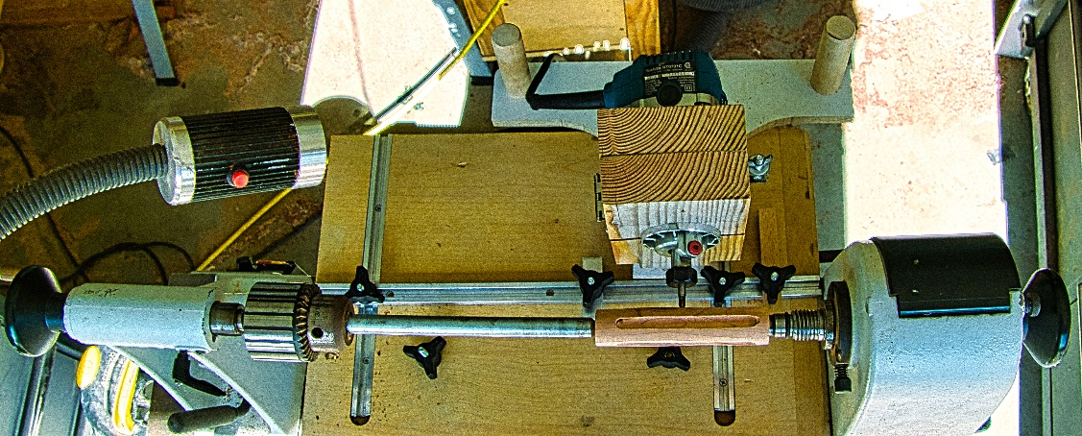

Once fluted, I polish the finished handle with a buffing wheel.
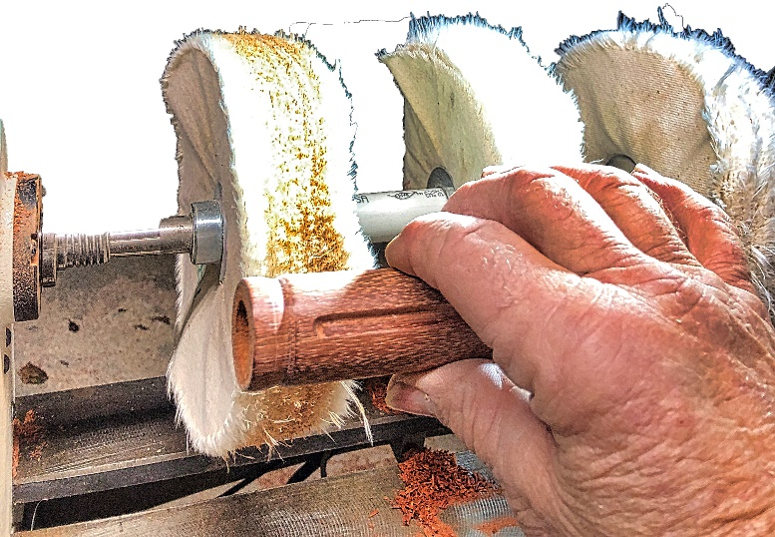

The screwdriver handle is glued to the screwdriver mechanism
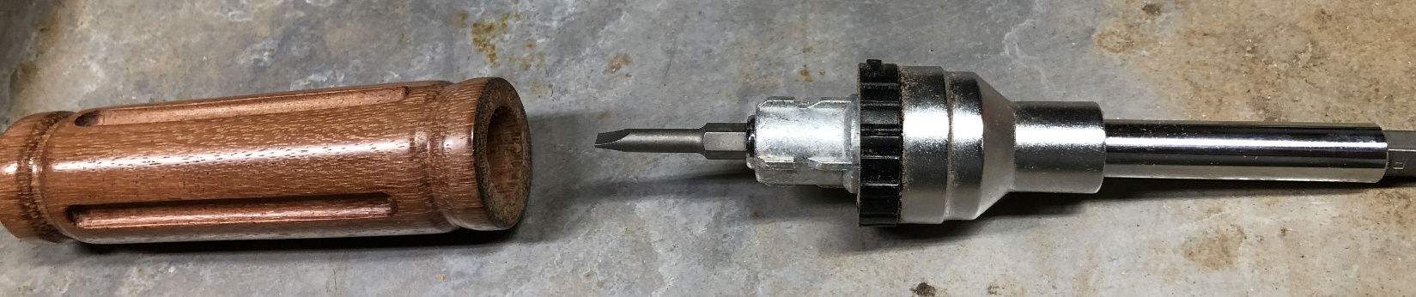
Some finished fluted screwdrivers
