Excel – Convert Seconds to Hours, Minutes and Seconds
If you want Excel to display the number of seconds in the form Hours:Minutes:Seconds, you will discover that the procedure has several steps that may not be obvious at first glance.
Example
Display 137 seconds in terms of minutes and seconds
Where M=Minutes, S=Seconds, the following formula
Try dividing 137 seconds by 60 to get minutes and seconds.
In Excel
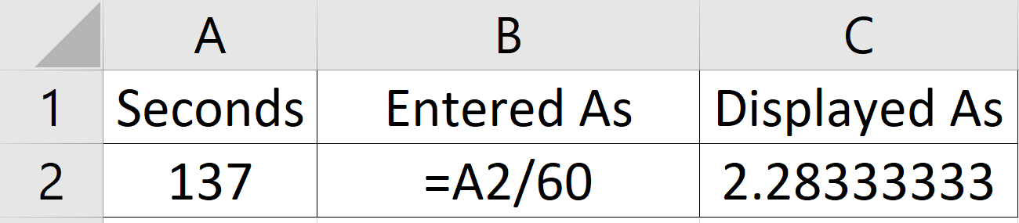
The result is 2.2833 because Excel states duration as a decimal, not the (hours):minutes:seconds format desired
To achieve the desired format, you have to change the formula to Hours=Seconds divided by 24 hours times 60 minutes times 60 seconds. In Excel, that is written =A1/(24*60*60)
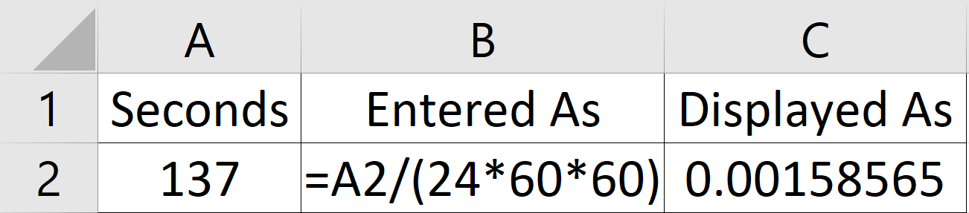
The result, 0.00158565, expresses duration in terms of 24 hours. To change the formatting to Hours, Minutes and Seconds, do the following
In the example above
Right click on Cell C2
Left Click on Format Cells
Left Click on Number/Custom
Select h:mm:ss
Left Click OK
Screen Capture follows
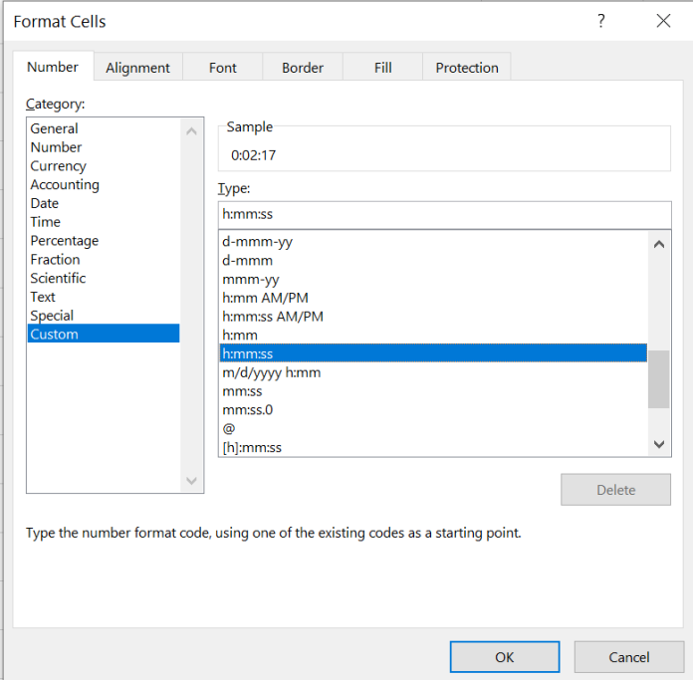

137 seconds now displays as 2 minutes 17 seconds

