Modification Notes – Kaldi Wide Coffee Roaster
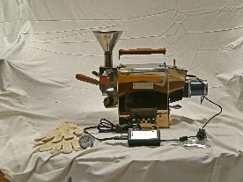
The Kaldi Wide Coffee Roaster is a no-frills, well-made machine manufactured in South Korea.
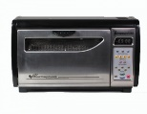
My first roaster was a Behmor 1600 that I subsequently upgraded to a Behmor 1600 Plus.
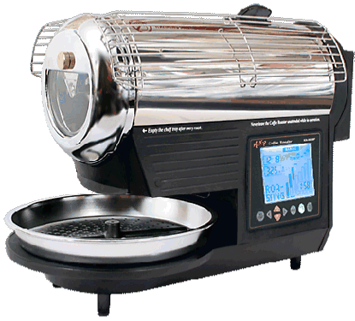
Next, I roasted with a Hottop KN 8828P 2K.
In both cases, I was frustrated. Though both machines have viewing windows and allow me to set roasting parameters, I didn’t have the control that I wanted.
As an avid home roaster, I am always looking for small batch/sample roasters. While there are numerous options, I could never find a quality roaster at a price that I was willing to pay. My ideal machine would be gas-fired, not electric. Since I was only roasting for myself and a few friends, I was in the market for a roast capacity of one pound or less.
One day, while searching the eBay, I came across the Kaldi Wide Coffee Roaster. Despite the numerous spelling errors in the listing, it held promise for me. Selling for $482.06 including expedited shipping, this seemed like a great value. The housing was all stainless steel. It had a small motor that apparently required 220 volts. That didn’t discourage me. I could easily add another circuit to the sub panel in my garage.
I placed an order for the machine on December 11th, 2017, paying with PayPal. The unit arrived on December 15th. It was carefully packed and undamaged in shipment.
When I opened the box, I discovered that the small motor that rotated the drum came with an adapter to convert a 220 volt plug to a 110 volt one. I was surprised that the roaster didn’t come with a heat source. Only when I re-read the on-line description more carefully did I realize that I would have to provide the heat. The manual suggested placing the unit on a stove and heating it that way. Since my cooktop is a glass surface with induction burners, that wouldn’t work.
I decided to heat with a small propane burner. My challenge lay in figuring out how to integrate the burner with the roaster. I wanted to stay with stainless steel parts whenever possible. I decided to mount the burner in a shallow stainless steel steam pan measuring roughly 6”x12”x2 ½”. This item can be found at many restaurant supply stores and is called a one quarter steam tray.
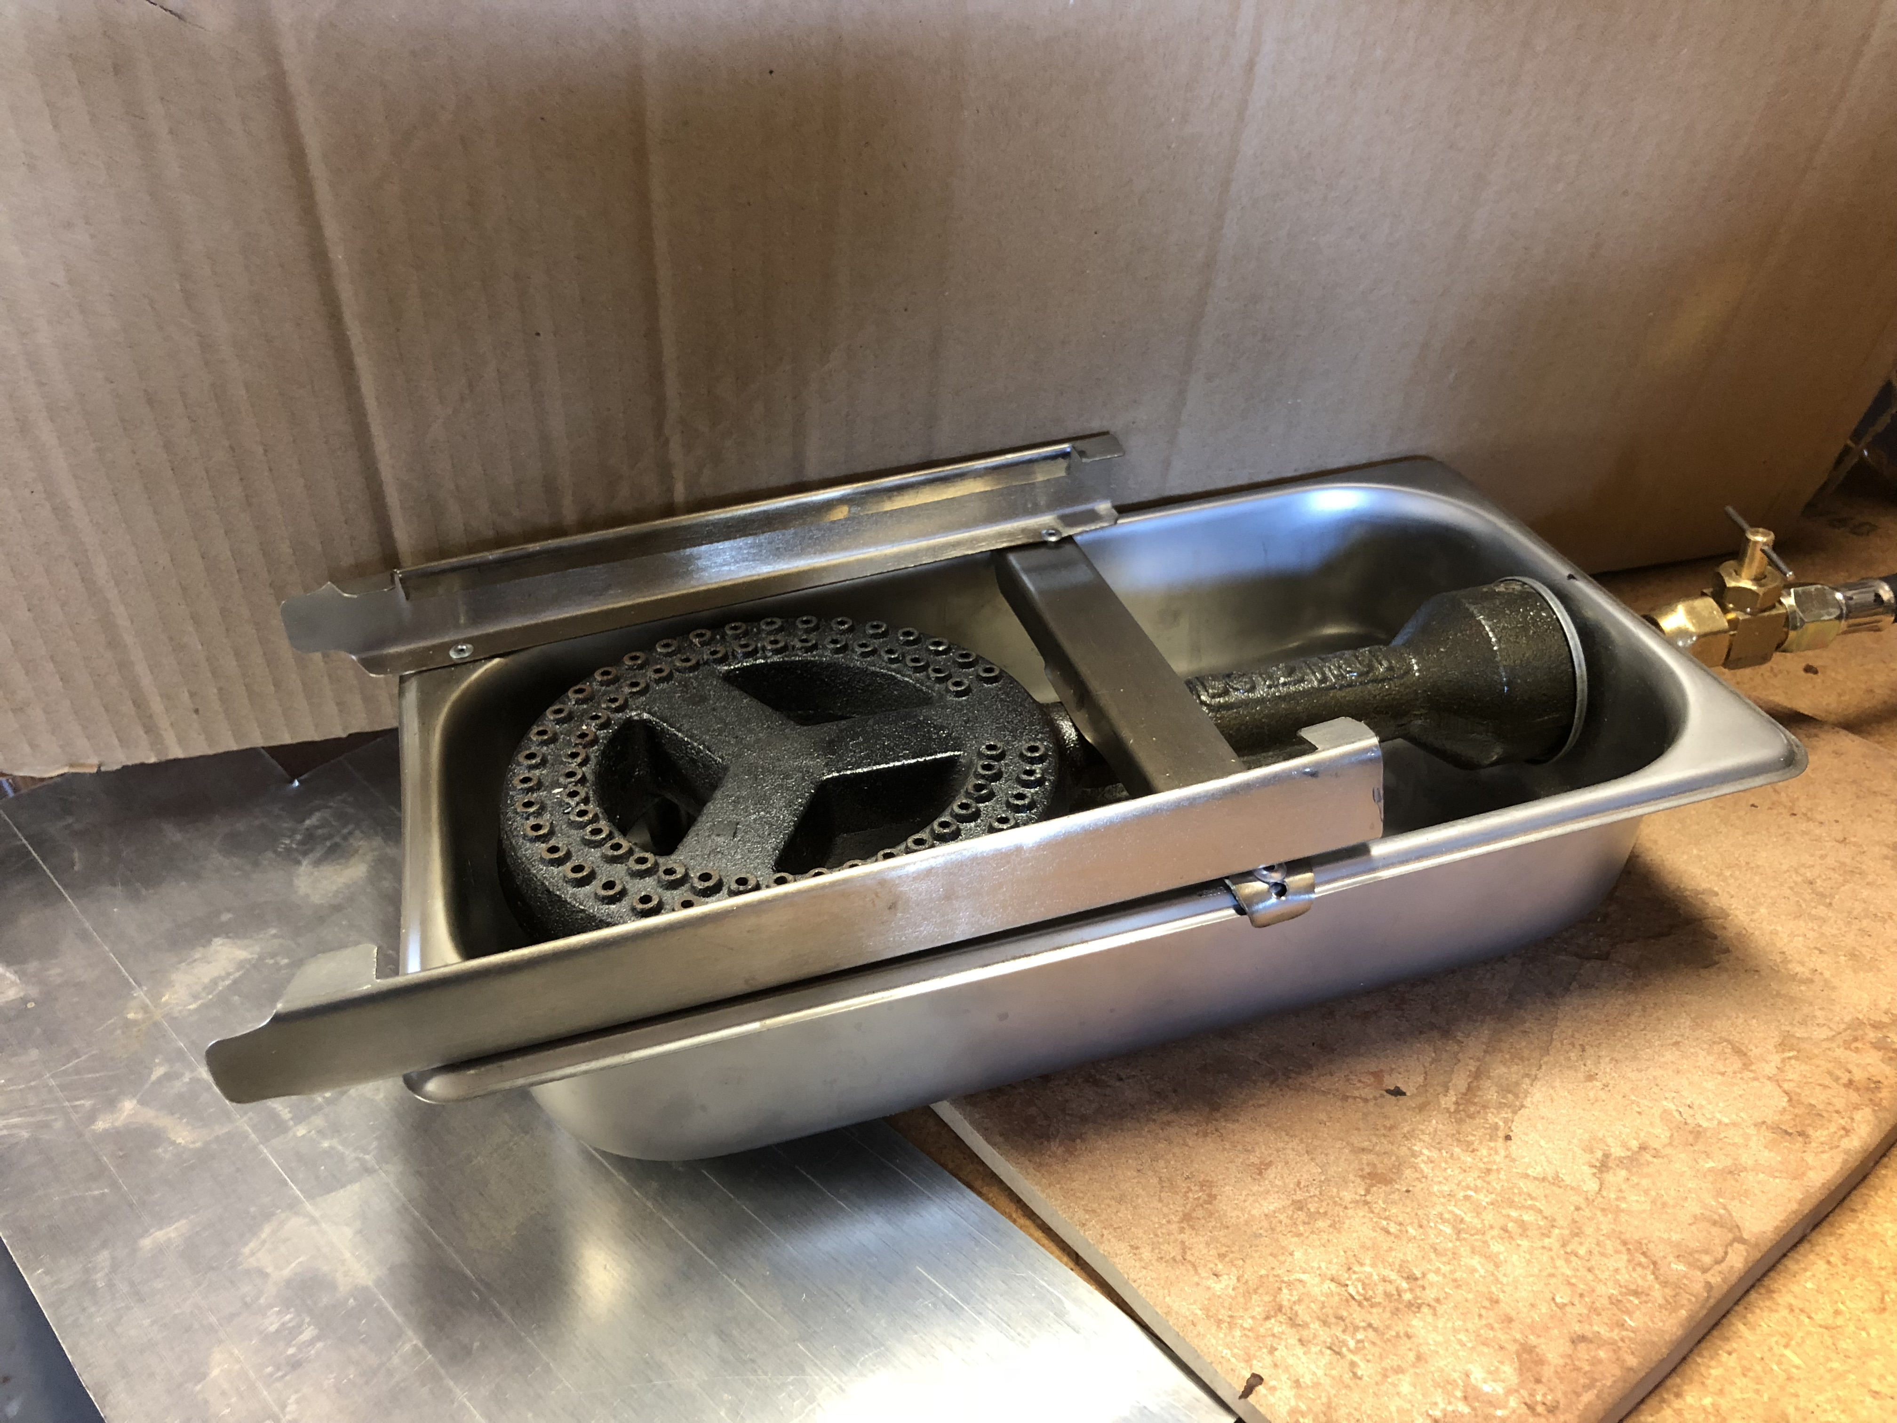
I fabricated rails for the two long sizes of the tray and added a cross brace across the middle.
I then added a needle valve to the propane line so that I could control the flame more precisely than with the shutoff valve on the propane tank.
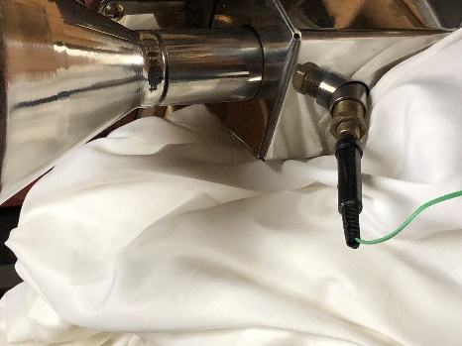
The roaster comes with an analog thermometer. I replaced it with a digital thermometer connected to a 6” thermocouple probe. The digital thermometer included a K-2 thermocouple, but the thermocouple consisted of 2 light wires. I opted for a 6” thermocouple probe, feeling that it would be more durable. I screwed a brass fitting into the hole for the analog thermometer and drilled it out to accommodate the thermocouple.
The roaster doesn’t have a cooling fan. I added a squirrel cage blower, mounting it on a steel plate. If the air flow was too strong, it might blow out the flame of the burner. The blower manufacturer warns against adding a speed control so I devised a different method to regulate the air flow. Initially, I designed a diverter valve so that I could either direct all the air to the slots along the top of the roaster or turn the valve and send the air away from the roaster. Given my limited sheet metal fabrication skills, I failed to create a valve that rotated smoothly and abandoned that idea.
Plan B was to simply affix a plate to the blower intake and control the air flow by moving the plate. While that solution probably isn’t recommended for blower longevity, I wasn’t too concerned. The blower would only run intermittently and for short periods of time.

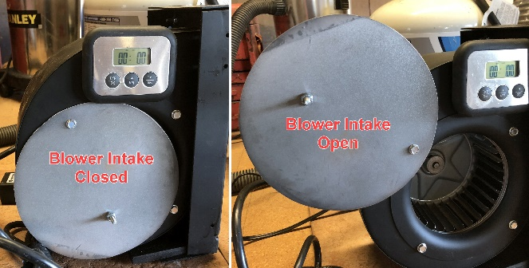
Since the blower is not attached to the roaster, I can vary the distance and the orientation of the air flow. I can also use the blower to cool the roasted beans at the end of the roast when I dump them into a large bowl.

I attached a digital timer to the blower so that I can keep track of the roasting timeline.
I made a switch box with toggle switches to control the blower and the drum rotation motor.
The setup rests on two ceramic floor tiles.
I added an aluminum plate to the bean hopper to keep the occasional bean from falling into the base of the hopper instead of into the roasting drum. (Not shown in the next image; See image further on in this document)
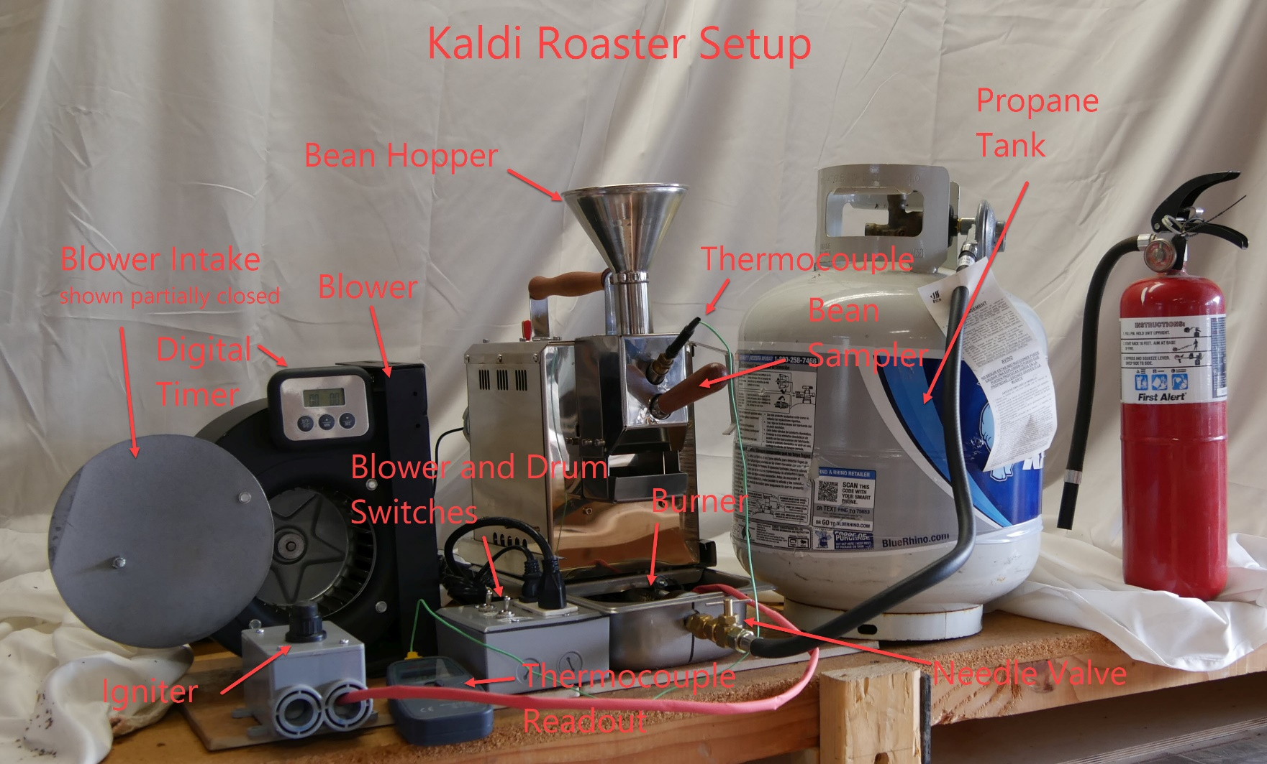
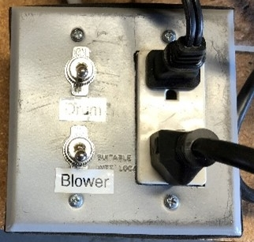
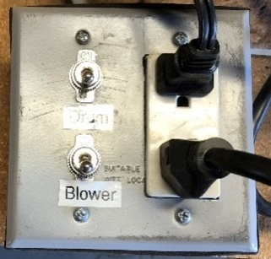
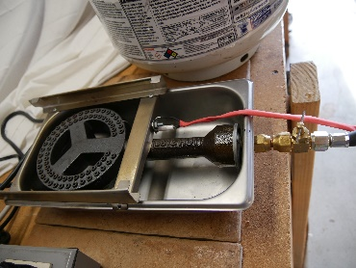
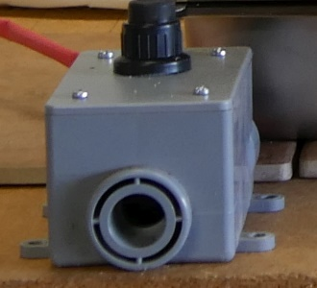
Switch Box Igniter Box Propane Burner/Igniter Detail

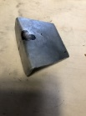
Bean Hopper Plate Bean Hopper Plate in Place
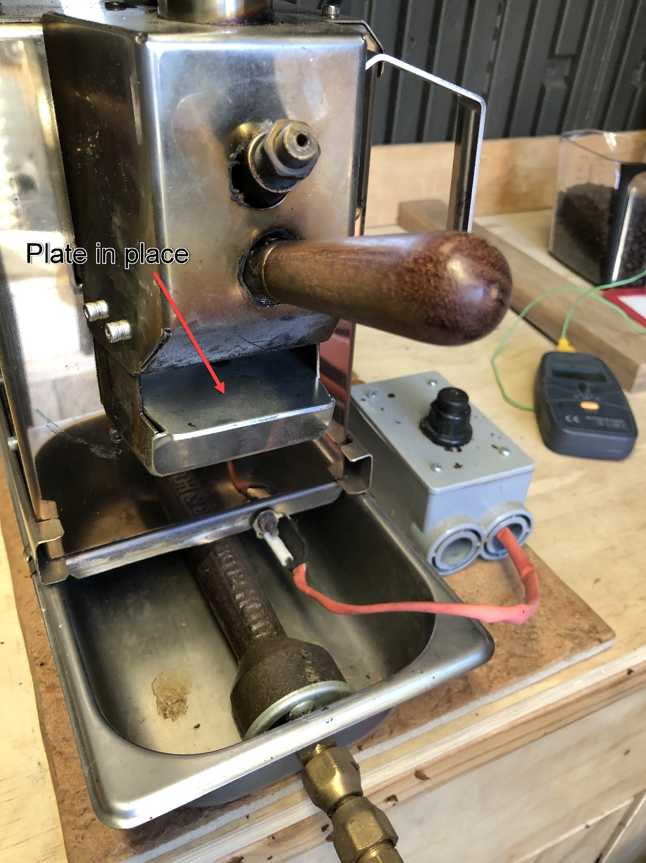

Data Logger
I added a data logger to my roaster setup in order to record roast times and temperatures. With that information, I can repeat successful roasts and avoid those that were less successful
After several false starts, I ended up purchasing a Heat Snob data logger. The $60 unit plugs into a PC via a USB-C to USB lead. The thermocouple plugs into the Heat Snob using Banana Plugs, the same Banana Plugs used to connect audio speaker to receivers.
Coffee Snob, the maker of Heat Snob, offers a free software application, Roast Monitor, that one downloads from http://coffeesnobs.com.au/RoastMonitor/RoastMonitor.exe
It requires Java in order to run. Java can be downloaded from the Oracle web site at https://java.com/
Many consider Java to be a security risk and avoid programs that rely on it.
Heat Snob Data Logger with thermocouple and USB cable
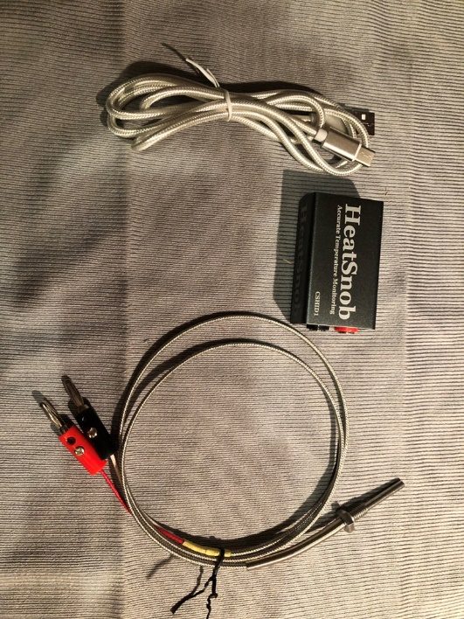
Thermocouple to replace the shorter thermocouple above (banana clips added, removing spade connectors)
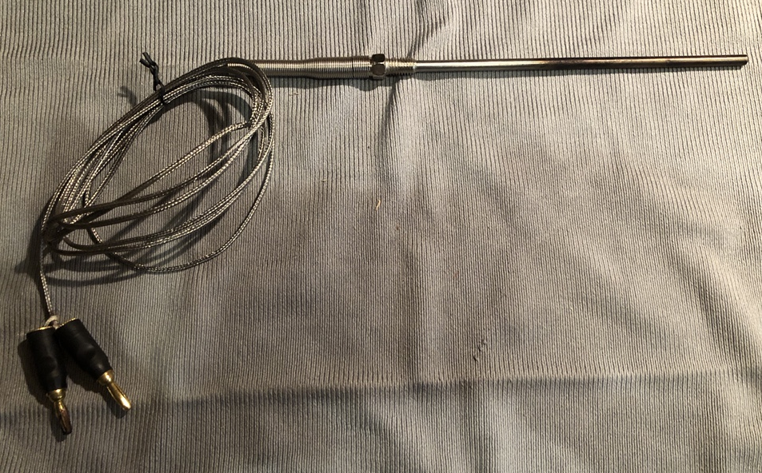
Sources
Note: The prices listed here were for purchases made in January 2021
Item | Supplier Link | Cost
Kaldi Wide Coffee Roaster | https://www.ebay.com/itm/Kaldi-Wide-Coffee-Bean-Roaster-Full-Set-Motor-Operated-for-Home-small-cafe-/142232864997 | $482.06
Propane Burner | https://www.amazon.com/gp/product/B0047O3PSO/ref=oh_aui_detailpage_o07_s01?ie=UTF8&psc=1 | $17.02
Blower | https://www.ebay.com/itm/Repl-for-Fasco-B45227-Centrifugal-Blower-Assembly-265-CFM-115-Volt-Single-Speed/142456621185?ssPageName=STRK%3AMEBIDX%3AIT&_trksid=p2057872.m2749.l2649 | $79.91
Digital Thermometer | https://www.sweetmarias.com/product/digital-thermometer-with-thermocouple | $29.90
6” Thermocouple | https://www.amazon.com/gp/product/B07BL4XPPP/ref=ppx_od_dt_b_asin_title_s00?ie=UTF8&psc=1 | $9.29
Heat Snob Data Logger | https://heatsnob.com/Shop.html | $60.00
2 Gang Aluminum Electrical Box | http://www.osh.com/Osh-Categories/Electrical/Rough-Electrical/Switches-%26-Outlets/Reddot-31-4-cu-in-2-Gang-Metal-Old-Work-Wall-Electrical-Box/p/6509723 | $10.99
2 Gang Aluminum Electrical Box Cover | http://www.osh.com/Osh-Categories/Electrical/Rough-Electrical/Switches-%26-Outlets/Gampak-2-Gang-Square-Metal-Electrical-Box-Cover/p/6626352 | $2.99
2 Toggle Switches | https://www.homedepot.com/p/Calterm-10-Amp-Metal-Toggle-Switch-with-Leads-41720/303616251 | $6.78
One Quarter Stainless Steel Steam Tray | http://www.bigtray.com/abc-steam-table-pan-st1402-sku-abcst1402-c-19800.html | $7.10
3/8-Inch Flare by 3/8-Inch Flare Straight Brass Needle Valve | https://www.amazon.com/gp/product/B008E5C7NG/ref=oh_aui_detailpage_o04_s00?ie=UTF8&psc=1 | $9.99
3/8”x3/8” Female Flared Brass Swivel | https://www.amazon.com/gp/product/B003WWRFTM/ref=oh_aui_detailpage_o02_s00?ie=UTF8&psc=1 | $7.35
6-Foot Propane Regulator Hose Kit | https://www.amazon.com/gp/product/B01M2DKPX0/ref=od_aui_detailpages00?ie=UTF8&psc=1 | $15.99
Digital Timer | https://www.amazon.com/Ikea-801-004-06-Fantast-Digital-Thermometer/dp/B00QKRL5S8/ref=sr_1_4 | $11.70
20 Pound Propane Cylinder | https://www.amazon.com/dp/B000FIVGYQ/ref=dp_cerb_3 | $27.98
18 AWG 2-Slot Non-Polarized Power Cord (6 Feet, Black) | https://www.amazon.com/gp/product/B0002J26K6/ref=oh_aui_detailpage_o08_s00?ie=UTF8&psc=1 | $4.78
GrillPartsPro Universal Electronic igniter Kit | https://www.amazon.com/gp/product/B07287PSH4/ref=od_aui_detailpages00?ie=UTF8&psc=1 | $9.99
1-Gang 19 cu. in. Type FS Box | https://www.homedepot.com/p/Carlon-1-Gang-19-cu-in-Type-FS-Box-E980FFN-CTN/100197880 | $6.05
BELL  1 Gang Blank Plastic Cover - Gray | https://www.homedepot.com/p/BELL-1-Gang-Blank-Plastic-Cover-Gray-PBC100GY/204125641 | $2.28
Total Expenses |  | $802.15
On 12/31/2022, I created a video that shows in detail how I roasted coffee with my Kaldi Roaster
View it at https://youtu.be/TJYLshM1atU

NOTES:
The original power cord for the roaster was designed for 220 volts. It included an adapter that plugged into it, allowing it to plug into a 110 volt outlet. The 220 volt power cord plugs into the 12 volt transformer. I purchased a 110 volt cord so I could eliminate the 220 volt to 110 volt adapter.
This list does not include some items that I already had on hand and didn’t have to purchase
3 Prong Electrical Plug for wiring the switch box
Sheet metal for fabricating the blower stand and baffle
Stainless steel for fabricating the rails on the propane burner tray
Assorted pop rivets, nuts and bolts
Flat Black Spray Paint
Threaded Brass Plug drilled to accept 6” Thermocouple probe and inserted in hole for the analog thermometer
2 Banana plugs for plugging the Thermocouple into the Heat Snob data logger
I did not actually use the 5-Foot Propane Regulator Hose Kit listed above. I already had a similar hose but it didn’t include a control valve. That valve was unnecessary since I used a needle valve downstream of the hose.
I didn’t purchase the propane cylinder listed above. I already had a similar item.
The igniter that I purchased had 3 terminals for 3 electrodes. Since I only used one electrode, I had to connect the two unused terminals to ground. Otherwise, they sparked between each other.
I made the bean hopper plate out of scrap aluminum that I had on hand. If I had stainless steel, I would have chosen it.
The plate proved to be ineffective. I was more successful in avoiding stray beans falling into the recess below the tryer by holding the bean hopper firmly against the body of the roaster when adding green beans.
Ralph Sutter; ralph@rsutter.com
For additional details, see www.fullbean.com/coffee/kaldi

